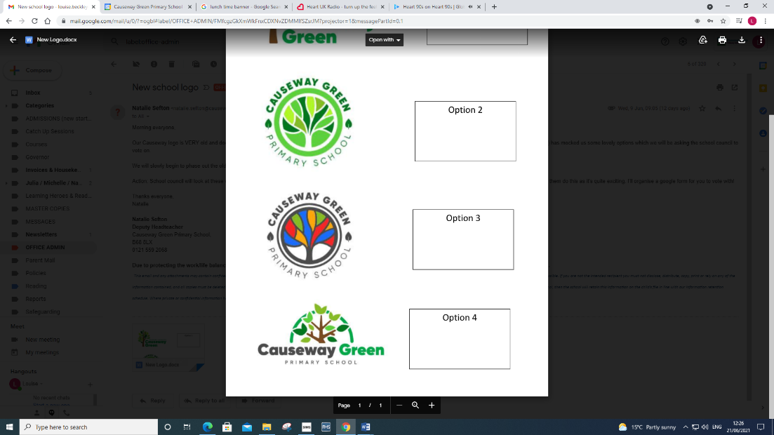
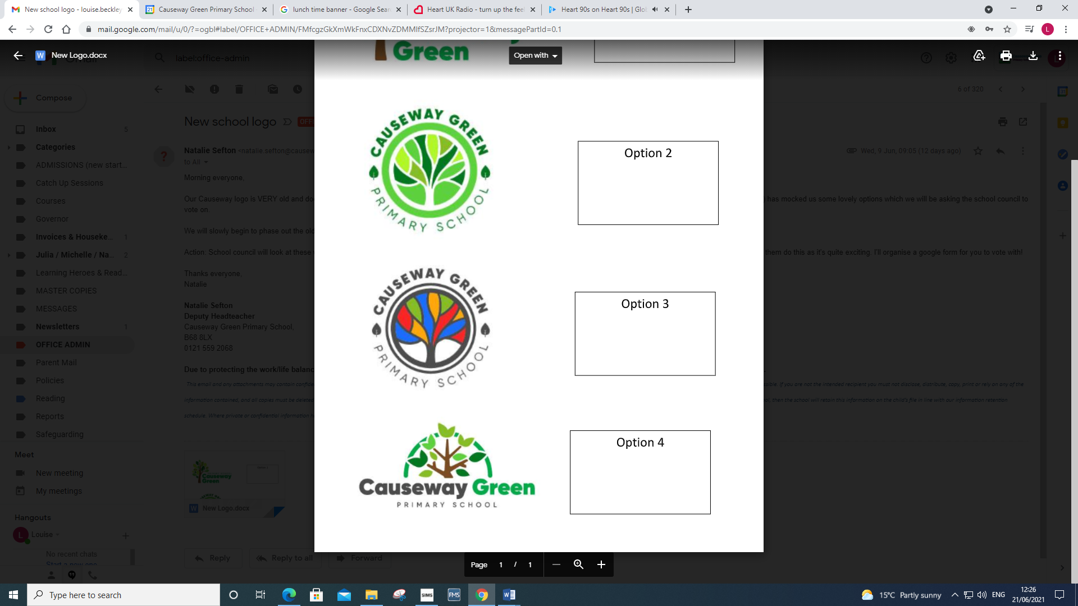 Causeway Green Primary School. Whole school provision map 2024-2025
Area of need | Wave 1 Quality First Teaching or ‘QFT’ | Wave 2 Additional small group work for children who are expected to catch-up with their peers as a result of a time-limited intervention. | Wave 3 Specific time-limited targeted intervention, for children identified as requiring SEN support. This involves focused teaching activities, which tackle fundamental errors, misconceptions and gaps in knowledge or understanding that prevents children from making progress. Interventions are delivered in small groups or on a 1:1 basis.
 | Provision | Provision | Provision
Cognition and Learning | - Differentiated curriculum.  - Differentiated outcomes  - Differentiated delivery  - Variety of learning styles considered.  - Differentiated Resources.  - Scaffolding leading to independence.  - Visual prompts aids  - Concrete resources | - Small group support English in class  - Small group support Maths in class  - Comprehension groups  - Boosters- Reading, Writing, Maths  - Sandwell Early Writing Intervention  - Responsive teaching groups  - Little Wandle catch-up (group) | - Individual support English/Maths  - Sandwell Early Writing Intervention (1:1)  - Multi-Sensory Spelling (Zero Tolerance spelling)  - Precision teaching  - 5-minute number box  - Individual reading  - Sandwell skills ladder curriculum.  - Lightning squad  - Little Wandle keep up (1:1)
Communica-tion and Interaction | - Flexible teaching arrangements.  - Structured school routine and class resources.  - Visual time table  - Visual aids  - Differentiated Curriculum delivery  - Use of symbols and pictures.  - Differentiated output | - Small group support English in class  - Small group support Maths in class  - Wellcomm (Amber)  - Topic webs/mats/mind maps  - Memory games  - Sequencing activities  - SULP | - Individual speech and language programme  - Individual in class support  - ASD structured teaching  - PEC’s / ALD  - Makaton  - Wellcomm (Red)  - Social stories / comic strip conversations  - Blank level questions  - COSST  - Intensive interaction  - Now and Next board
Social, Emotional and Mental Health | - Emotion coaching whole school approach.  - Behaviour policy (Behaviour Recovery).  - Whole school class rules  - British values  - Jigsaw (PSHE) programme  - Circle time. | - Small group circle time  - Nurture principles small group PHSE groups.  - Family intervention support (FLO)  - Individual behaviour plans and trackers  - Positive relationships and team building groups (sports mentor)  - Lego Therapy  - TEAMTEACHH training de-escalation (moving to CPI this academic year) | - Key worker  - Individual behaviour plan.  - Family intervention support (FLO)  - Mentoring  - Social stories / comic strip conversations  - Krunch mentoring  - Counselling services- Kaleidoscope, Murrays Hall, Edward’s trust  - TEAMTEACHH training with physical intervention (moving to CPI this academic year)  - PPE support  - Believe to achieve
Sensory and Physical | - Flexible teaching arrangements.  - Teacher awareness of sensory (V1/H1/PD) needs of pupil.  - Availability of resources  - Squiggle while you wiggle  - Organisation of classroom  - Adapted resources | - Additional handwriting  - Dough Disco | - Penpal 1:1  - OT/ physiotherapy advised resources.  - TEACCH (ASD structured teaching – use of sensory sessions and equipment)  - VI/ H1 support  - PD support  - Fun fit
Medical | - Epi-pen training  - Asthma training | - Diabetes Training / Epilepsy training | - Individual Epilepsy / Individual Diabetes support

